Session 3: The Thanksgiving Psalms (Psalm 73)

‘Thanksgiving psalms occupy a territory that lies somewhere between praise and lament. Like the laments, thanksgiving psalms are only too well aware of the reality of pain in all its forms. The heart of most thanksgiving psalms is a narrative of sin, treachery, oppression, suffering, or threat that characterizes the disordered world of the psalmist. The distinction that sets these narratives apart from those present in lament psalms is one of time. For the lament, suffering describes the present and continuing experience of the psalmist, while in thanksgiving psalms the suffering and pain described lie in the past.’ – Gerald Wilson, Psalms Vol 1: 65-66.

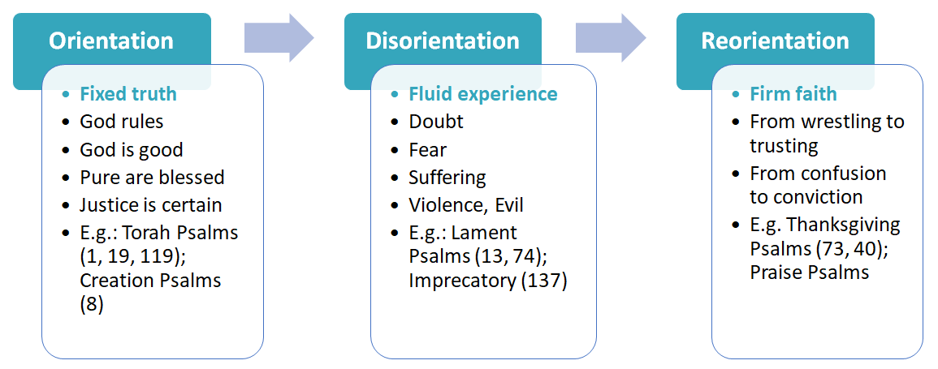

Asaph the Author
- Chief of the music ministers when David brought the ark of the covenant to Jerusalem (1 Chr 6:31,39; 15:16-17; 16:5)
- ‘King Hezekiah…ordered the Levites to praise the LORD with the words of David and of Asaph the seer. So they sang praises with gladness and bowed down and worshiped’ (2 Chr 29:30).
- Asaph is credited with twelve psalms (50, 73-83), though some are post-exilic (e.g. 74) so probably from the ‘Asaph Guild’ or his descendants.
- This psalm, the most personal, is almost certainly from the ‘original’ Asaph from David’s day.

Asaph’s Creed:

God blesses the pure in heart (Ps 73:1)

Asaph in Crisis

from short-term comparisons (Ps 73:2-14,16)

The wicked prosper (2-12)

The righteous are punished (14)

Purity seems pointless (13)

‘it troubled me deeply’ (16)
Asaph gets Clarity
about ultimate realities (Ps 73:15-22)

- He enters God’s presence (17a)

- He gains true perspective

  - The wicked (17b-20, 27)

    - are on the slippery slope, suddenly swept away

    - will be destroyed and perish

  - The righteous (23-26, 28)

    - enjoy God as their refuge now

    - experience eternity with Him forever

- He responds with penitence (21-22) and praise (28)

Stay faithful and you’ll see that God richly rewards the pure in heart!

Takeaways

- Don’t be surprised by the prosperity of the ‘godless’ and the pain of the ‘godly’; any one at any age or stage can have a crisis of faith
- To gain true perspective in our fallen world, we desperately need God’s precepts, presence, ‘place’, and people
- Be honest about your faith struggles, but careful of context
- Take the long view, and you’ll see that God richly rewards the pure in heart!

______________________________

Excursus on Self-Justification

What are we to make of Asaph’s (Ps 73:13), David’s & other psalmists’ protestations of innocence? (See Ps 17:3; 18:20-24; 26:1.) Their claims appear to be self-justification and hubris in the extreme—totally at odds with scriptures like Ro 3:23: ‘all have sinned and fall short of the glory of God’.
1. Consider [the wider literary] context:
- This is wisdom literature, which includes generalizations
- This is poetry, which uses hyperbole (exaggeration or overstatement)
- This is Israelite covenant literature: righteousness already defined by God (cf. Ps 1; Jer 17:5-8; Deut 28)
2. Know the benchmark. The comparison is not with God in his holy perfection, but other fallen humans. The psalmist is not claiming absolute righteousness, but relative human righteousness.
3. Picture a divine courtroom. The psalmist pictures himself in Yahweh’s court claiming not sinlessness but innocence of specific charges, unfairness of his treatment etc.
4. Count their confessions. In other psalms, the same ‘faultless’ psalmists readily confess their sins demonstrating their other claims are relative. (E.g. Asaph in 73:3: ‘I had nearly lost my foothold. For I envied the arrogant’. ‘When my heart was grieved and my spirit embittered, I was senseless and ignorant’. E.g. David in Ps 51:3: ‘my sin is always before me.’)

