Session 4: The Messianic Psalms (Psalm 2)

1. The meaning of ‘messianic’: to do with ‘the Anointed One’
- In the OT, prophets, priests & kings were anointed with special oil
- The failures of the kings created a longing for the Anointed One, the Messiah, which is reflected in the messianic psalms (cf. Dan 9:25-26)
- Jesus claimed to be/was recognized by many as the promised Messiah (Jn 4:25-26; Mt 16:13-20; Jn 11:25-27; Jn 10:24-26; Mk 14:61-62)
- As the Anointed One/Messiah/Christ, he uniquely fulfils the roles of prophet, priest and king (Heb 1:1-3)
- So the OT is messianic in that it in that it increasingly anticipates the coming Messiah. The NT is messianic in that it announces that the Messiah has come. And He is Jesus!

‘The Messiah is the eschatological, royal, Servant of the Lord, springing from the Davidic dynasty, who is consecrated by God to provide redemption from sin, bring deliverance for Israel, rule the world, and establish a kingdom of peace, justice and righteousness’ -Michael Rydelnik, Moody Handbook of Messianic Prophecy, p. 32.

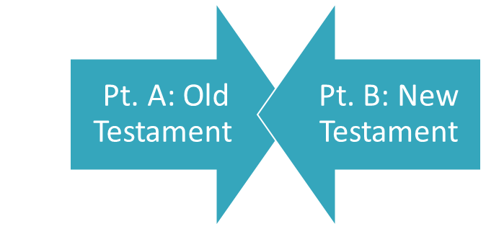

2. Jesus’ claim about the Old Testament
- ‘Everything must be fulfilled that is written about me in the Law of Moses, the Prophets and the Psalms’ (Lk 24:44)
- ‘Jesus found himself in the Old Testament, a thing that some modern scholars do not seem able to do’ – A.T. Robinson.
- TANAKH: Torah: Law of Moses; Nevi’im: Prophets; Ketuvim: Writings

3. Jesus’ claim about the Psalms
- ‘written about me in the… Psalms’: the psalms speak about Jesus
- ‘everything must be fulfilled’: what the psalms say about Jesus:
  - is true (Jn 17:17)
  - was fulfilled in Jesus’ life, death, resurrection, ascension, session
  - will be fulfilled in Jesus’ return, rule and reign as the Davidic King

4. How can the psalmists possibly know about Jesus?
- Jesus: ‘David…speaking by the Holy Spirit, declared…’ (Mk 12:36/ Ps 110)
- Peter: ‘David… was a prophet and knew that God had promised on oath that he would place one of his descendants on his throne. Seeing what was to come, he spoke of the resurrection of Messiah…’ (Ac 2:24-31/ Ps 16:9-11)
- David knew God’s covenant, wrote by inspiration of the Spirit, and prophetically re Messiah
- Asaph, Heman, Jeduthun & sons (other psalmists) were also musician-prophets (1 Chr 25:1-4; 2 Chr 35:15)

5. Messiah, the focus of both testaments

6. The various ways Messianic Psalms write about / point to Jesus:
- Directly: The psalm writes solely about Jesus (Ps 110 where David calls Messiah his ‘Lord’)
- Historically: The psalm writes about a contemporary Davidic king/enthronement, but the language clearly applies to someone much greater (e.g., enthronement psalms 2, 45, 72)
- Theocratically: The psalm writes about the Lord’s coming and earthly kingdom without mentioning a Davidic king, but in terms that other Scriptures indicate clearly refer to Christ (e.g., the enthronement psalms 96-99).
- Personally: The psalm writes about the psalmist’s own experience, but the language goes beyond that experience and becomes historically true in Jesus (e.g., Ps 22: ‘pierce my hands & feet’)
- ‘Coindidentally’: The psalm contains an isolated line which the NT writers consider ‘inspired coincidence’ since it corresponds to an event in Messiah’s life (e.g., Ps 34:20: none of his bones broken)

7. Which psalms are messianic?
- Many scholars would say some 16 psalms (10%) are messianic: Ps 2, 8, 16, 22, 31, 34, 40, 41, 45, 68, 69, 72, 78, 102, 110, and 118.
- They include descriptions of:
  - Jesus’ deity, kingly status and rule
  - What Jesus did and said and prayed, and how
  - What people said and did to him, and why
  - What God said and did to him
- Different parts of these psalms are quoted multiple times in the NT as indicated by this chart from The Harvest Bible Handbook, p. 241ff.
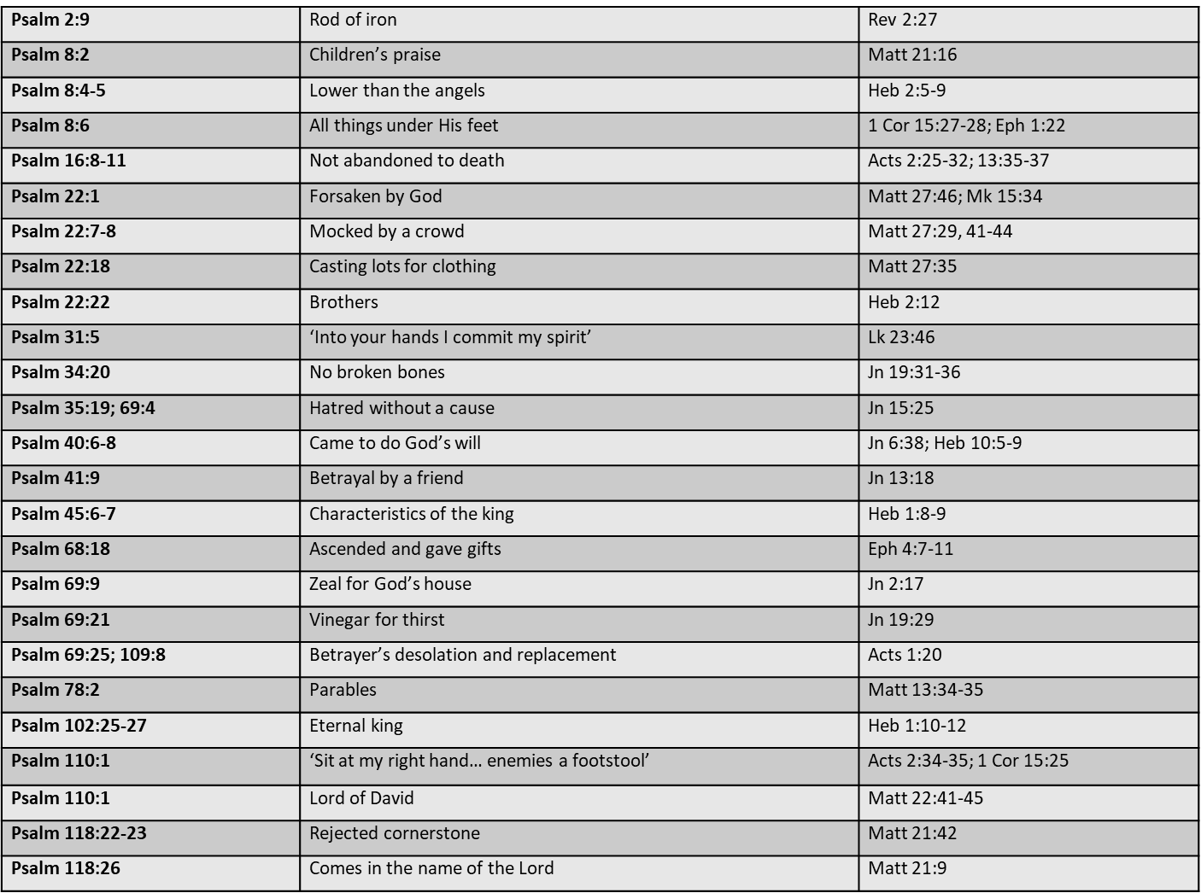

5. Some key Messianic Psalms and themes:
- Psalm 2: Christ the Anointed Son & King
- Psalm 8: Christ’s dominion
- Psalm 16: Christ’s resurrection
- Psalm 22: Christ’s sufferings
- Psalm 40: Christ’s obedience
- Psalm 41: Christ’s betrayal
- Psalm 45: Christ’s deity & righteousness
- Psalm 68: Christ’s ascension
- Psalm 110: Christ’s deity and exaltation
- Psalm 118: Christ the chief cornerstone

Psalm 2: Yahweh & His Anointed Rule/Ruler

- Part of the Ps 1-2 Introduction to the Psalter
- A royal/enthronement/messianic psalm
- A psalm of David (Acts 4:25-26)
- Rooted in the Davidic covenant, 2 Samuel 7

I. Rebellion of the Nations (1-3)
The rebels speak in v3

II. Response of the Lord (4-6)
God speaks in v6

III. Rule of the Messiah (7-9)
Messiah speaks in v7-9, quoting God his Father

IV. Requirements of their Subjects (10-12)
The psalmist ‘speaks’ in v10-12

END NOTES: See Hugh Ross citing Franz Delitzsch in “Psalms” in The Bible Knowledge Commentary (Victor, 1989), 789-790.

